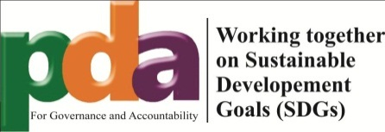

**National Stakeholders Consultation Workshop**

**Voluntary National Review Process- Focusing on Rights of Persons with Disabilities**

**20th Nov, 2018 at Islamabad**

Pakistan is going to present Voluntary National Review Report on SDDs in HLPF in 2019. In order to extract some key learning and recommendations for SDGs implementation status in the context of disability rights, Sightsavers, AwazCDS-Pakistan and Pakistan Development Alliance (PDA) collaboratively organized a one day National Consultation workshop on VNR Report process on 20th Nov, 2018 at Islamabad. In this consultation workshop representative from Government line Departments i.e Federal SDG Unit, Ministry of Planning and Development, Social Welfare and Special Education Departments CSOs, INGOs, Disable Person Organizations (DPOs) from all over Pakistan participated and shared their inputs and recommendations for the VNR report process.

**Objectives of National Consultation:**

* To make Govt VNR report process more inclusive by engaging PWDs and Disable Person organizations
* To share key recommendations with Govt for SDGs implementation status in the context of disability rights

The representatives of Government from different regions and Provinces of Pakistan shared the initiatives taken so far for the implementation of SDGs and also highlighted the measures taken by the Government to address the issues and challenges faced by PWDs.

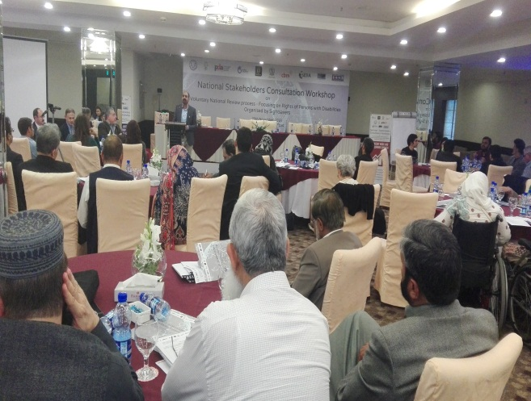This event was graced by the participation of Mr. Shahid Naeem-Chief Federal SDG unit and Ms. Kanwal Shauzab Parliamentary Secretaries Planning, Development and Reforms. They appreciated the efforts of CSOs in Pakistan for initiating the Citizen’s led VNR Report Process in Pakistan by engaging PWDs and Disable Person organizations. They ensured to incorporate the key recommendations of this National Consultation in Govt VNR Report.

Mr. Zia Ur Rehman- CE AwazCDS Pakistan and National Coordinator PDA shared his views regarding VNR Report process and requirements. He shared with participants that Government is focusing to prepare process oriented report for VNR rather than target or progress oriented report. He further added that Pakistan Development Alliance is going to initiate People led VNR Report Process which is a bottom up approach and geographically all over Pakistan will be reached out to have the information about SDGs implementation from grass-root level. In order to ensure this consultation process inclusive, District and Local Govt Departments, Pakistan Development Alliance members, CSOs, Academia, young people, religious minorities, PWDs and other marginalized groups will be taken onboard for their inputs. This consultative process will be completed till April, 2019.

Mr. Shahid Naeem-Chief Federal SDG unit showed contentment on the inception of consultation process for VNR at National level. He shared the details with participants regarding the Government VNR report process and progress so far. He shared that previously during MDGs, there were two main reasons that Pakistan could not achieve the targets. 1stly, the targets of MDGs were very ambitious to achieve and the second reason was that at National level no political platform was available from where the line Departments may seek guidance for the MDGs report which would identify the grey areas and requirement of policy formation etc. This was a lesson learnt. However this time, the Government of Pakistan is very much committed toward the achievement of SDGs and VNR reporting. The Government of Pakistan is proposing a National Advisory Committee. The representation form all Provinces and regions will be ensured in this Committee and Minister of Planning will chair this committee. There will be a steering Committee under National Advisory Committee, all the executive head of different Departments will be part of Steering Committee and it will be responsible to implement the advice of the National Advisory Committee. He further added that in MDGs, there were only 23indicators for the report however in SDGs the total indicators are 245 and we require gathering the data as per these indicators. This is a huge task and it requires a lot of budgetary allocations. For the data collection, first of all we require to specify the indicators for which data may be collected from the field. The Government intends to resolve this apprehension more efficiently as some effective systems are being introduced for the data collection. Therefore during the VNR report at HLPF in 2019, Government intends to focus on the reporting of the key achievements. As per the VNR report guidelines, VNR report will not relay on Government report only as there is a system of parallel reporting as the alternate VNR report will be prepared by the Civil Society of Pakistan as well. The Government is strategizing for the data collection systematically so that the next time progress of SDGs indicators may be presented at HLPF.